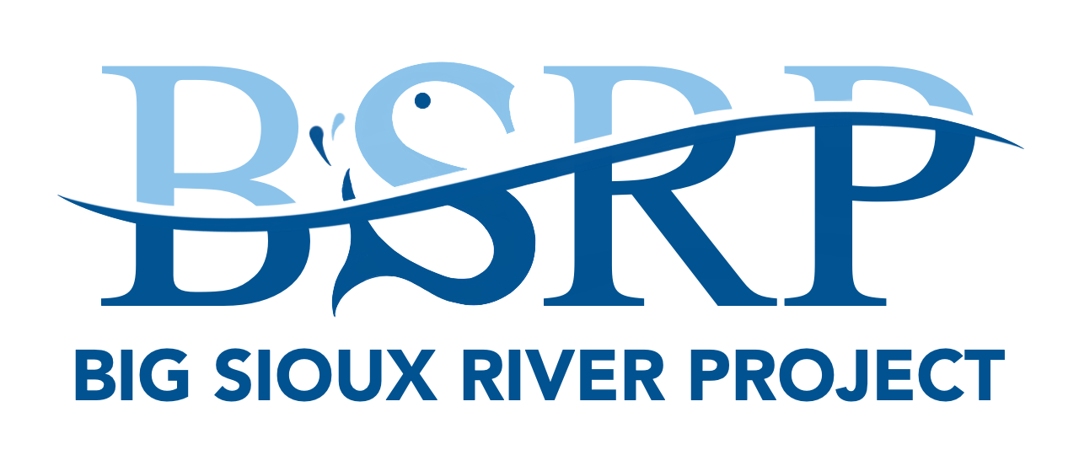
BIG SIOUX RIVER PROJECT
Livestock Water Development
Project Application

Name |  | Phone

Email

Address

Legal Description |  | Estimated Acres

Pasture Owned or Rented? |  | If Rented, who is the owner?

By signing this form, I understand that:

- This application is subject to the approval of the Big Sioux River Project (BSRP) Senior Watershed Coordinator and the Minnehaha Conservation District (MCD) based on project priorities. You must obtain prior approval for any work planned to be eligible for cost-share.

- Eligible acres will be determined by the Project Coordinator and South Dakota Department of Agriculture and Natural Resources (SD DANR) based on factors including but not limited to: located within the Big Sioux River watershed and proximity to a priority 303(d) impaired water body.

- All invoices and receipts must be submitted to the Big Sioux River Project to be eligible for cost-share reimbursement. If applicable, 75% of actual cost for pipeline, tanks, hydrants, heavy-use protection, and their respective installation will be provided.

Participant |  | Date

** Any questions can be directed to BSRP Senior Watershed Coordinator Barry Berg (605) 759-2650 **
Please mail paper applications to 1307 Clark Ave. Dell Rapids, SD 57022.

Practice Certification:
Pipeline: Linear Feet |  | Cost |  | Cost-Share (75% of total)
Tanks: # of Tanks |  | Cost |  | Cost-Share (75% of total)
Wells: # of Wells |  | Cost |  | Cost-Share (75% of total)

Certified By: |  | Total Cost $ |  | SRF $ |  | Match $
 | (Initial/Date)

Estimated Cost Worksheet:

Pipeline: Linear Feet |  | Cost
Tanks: # of Tanks |  | Cost
Wells: # of Wells |  | Cost

